UI/UX · Web App · 2026

BiteSplit
Group food ordering, without the math fight at the end.
A collaborative web app where a group orders from one shared cart in real time — and the bill splits itself, to the rupee, before anyone pays.
Turned the messiest part of group food ordering — the “who owes what” — into a self-resolving, real-time checkout.
Role | UI/UX Designer & Frontend Developer (full-stack build with AI pair-programming)
Type | Self-initiated proof of concept · 1-week sprint
Stack | React 18 · TypeScript · Tailwind CSS · Framer Motion · Socket.io · Node / Express

The Problem
Ordering food for a group is a coordination tax everyone has paid and nobody enjoys. It breaks down in three predictable places:
- One person becomes the human order form. The host collects picks over chat, fixes the “wait, no onions,” and types it all into one account. Items get missed; the order goes in late.
- The host eats the bill. They pay upfront, then back-calculate what each person owes — items plus their share of delivery, tax, and tip — and chase people for ₹230 three days later.
- Nobody can see the shared cart. Delivery apps are single-device, so the group orders blind: duplicate fries, lopsided meals, no real-time alignment.

The Goal
Replace the chat + spreadsheet + IOU ritual with one shared session where anyone joins with zero signup, everyone sees the same live cart, and the bill splits itself correctly before checkout — so the host is never out of pocket and no one does mental math.

The Experience, Step by Step

1. Join in one field
The host starts a session and gets a short, shareable room code. Guests open the link, see the code pre-filled, and tap Join — no account, no password, no install. Removing friction at the door is why the group actually shows up.
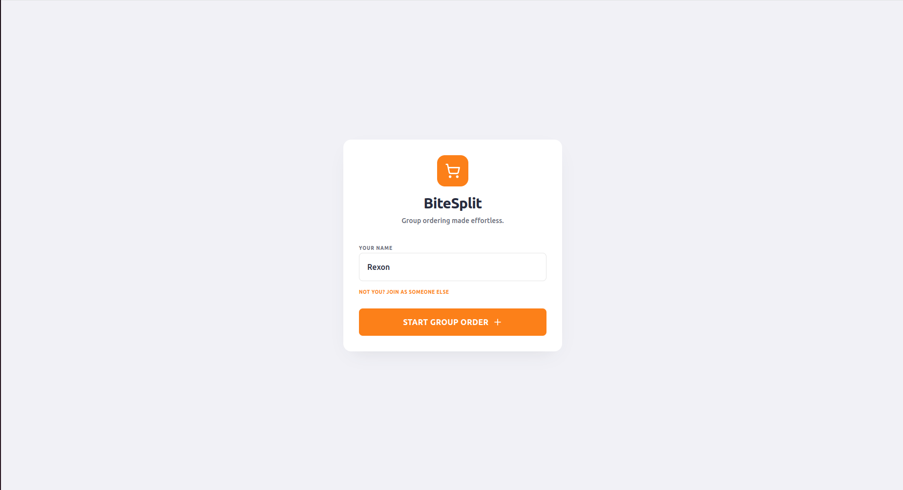  Host starts a group order with just a name. | 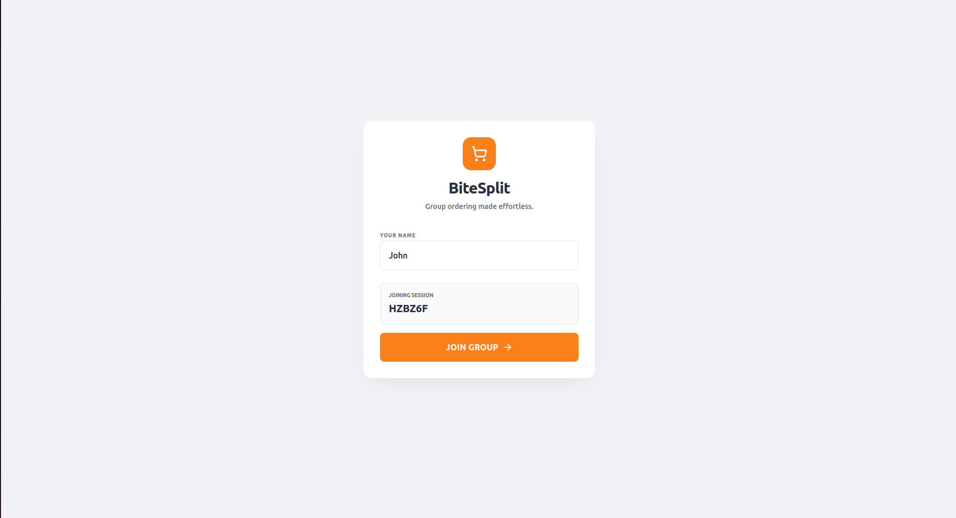  Guests join the session with the code pre-filled.

2. Pick where you’re ordering from
A familiar restaurant grid — rating, prep time, distance — so nobody needs instructions. Choosing one loads that restaurant’s real menu, not a generic template.
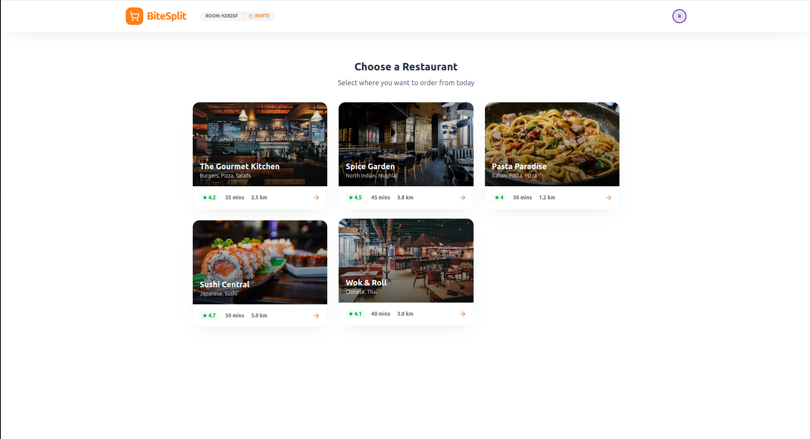
Restaurant selection, shared across everyone in the room.

3. The shared cart is the centerpiece
The menu sits on the left with search and category filters; the Shared Cart sits on the right and is the heart of the product. Items are grouped per person, so everyone sees exactly who ordered what — live. Every add, edit, and remove broadcasts instantly to all devices via Socket.io, which kills duplicate orders.
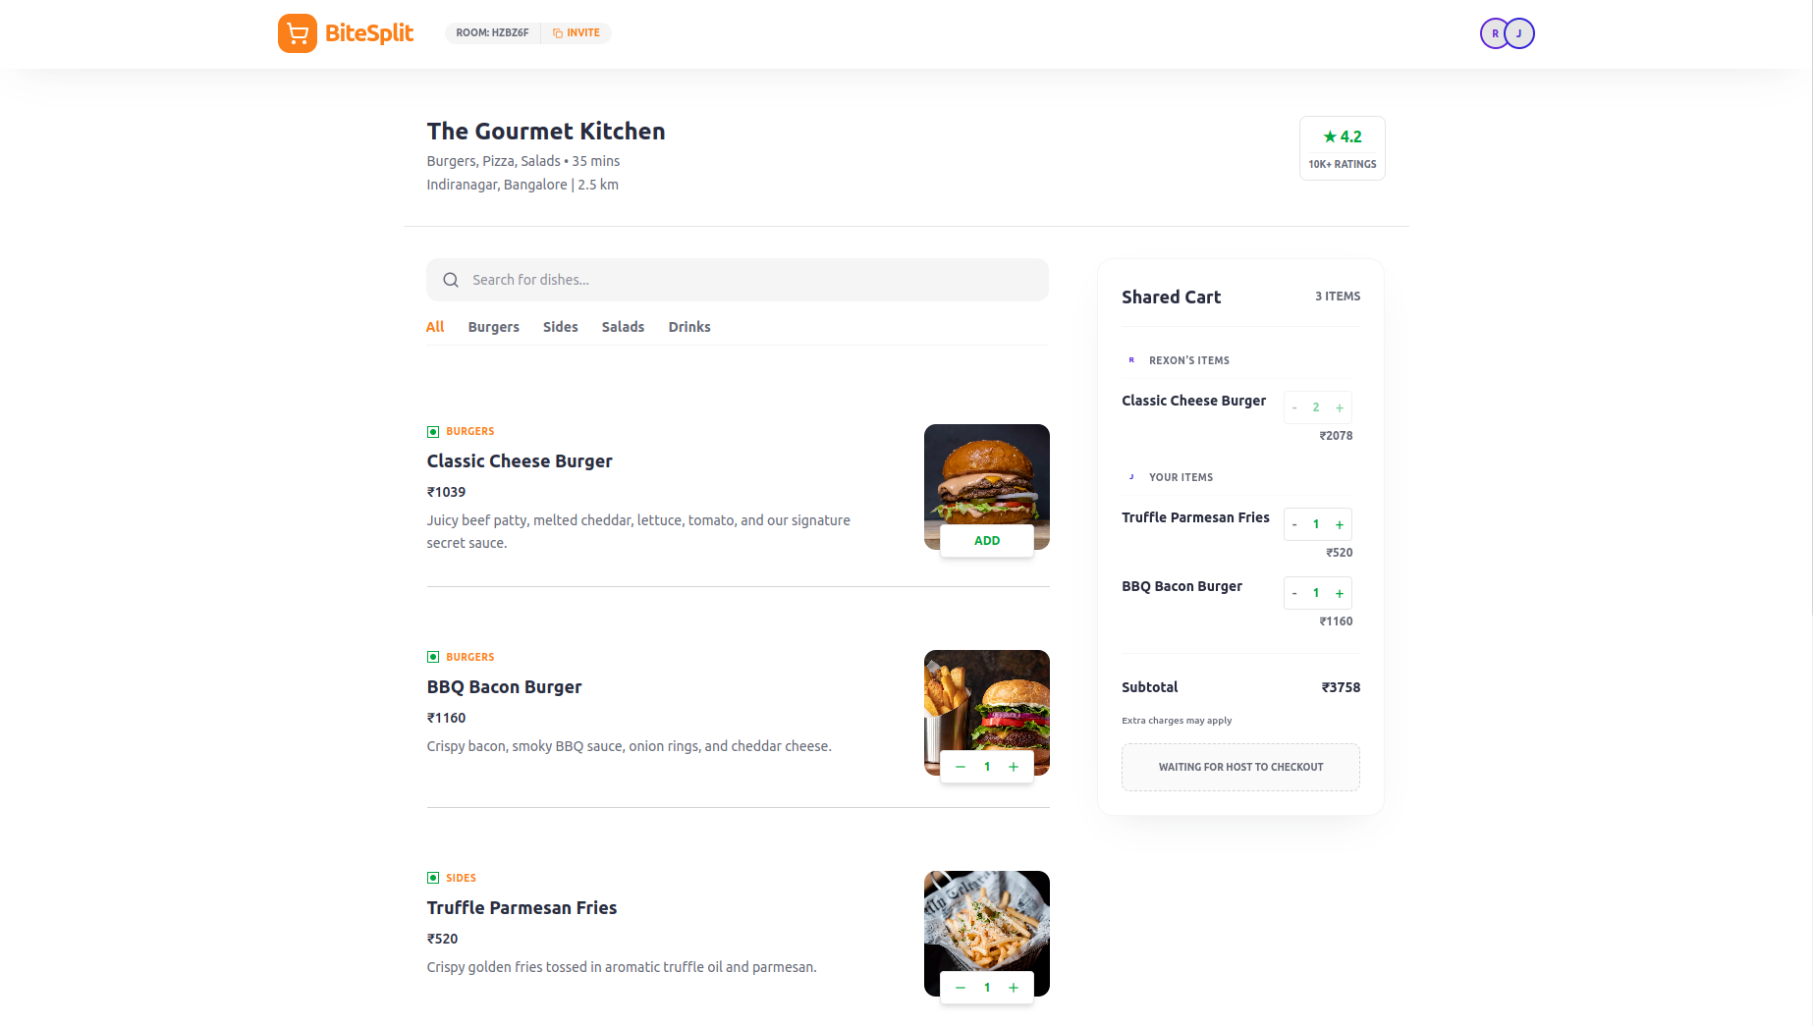
Live shared cart — items grouped by person, updating in real time for everyone.

4. The bill splits itself
At checkout the host gets Individual Shares with a Proportional / Equal toggle, a tip selector, and a transparent breakdown — items, delivery, taxes, total. Every member reviews and approves their own share, and the host can’t pay until everyone has — the pay button stays disabled while “2 members haven’t approved yet.”
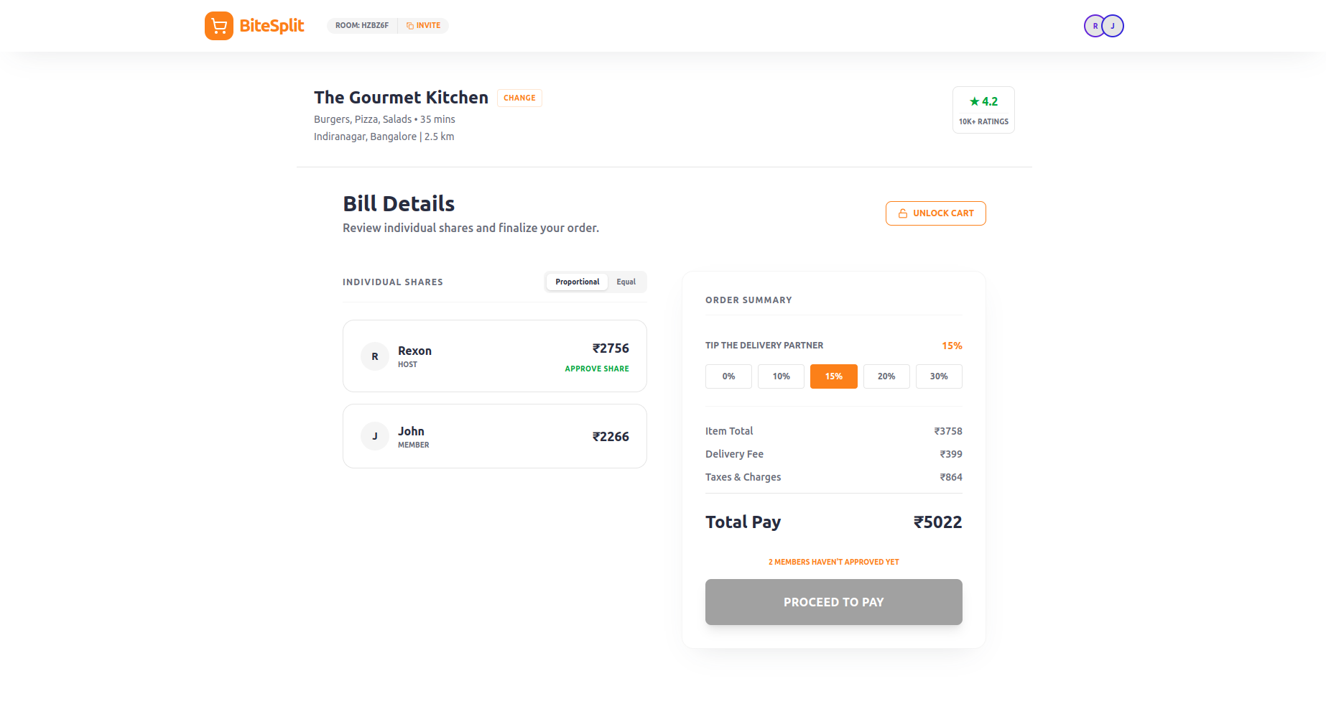  Host view — pay locked until all members approve. | 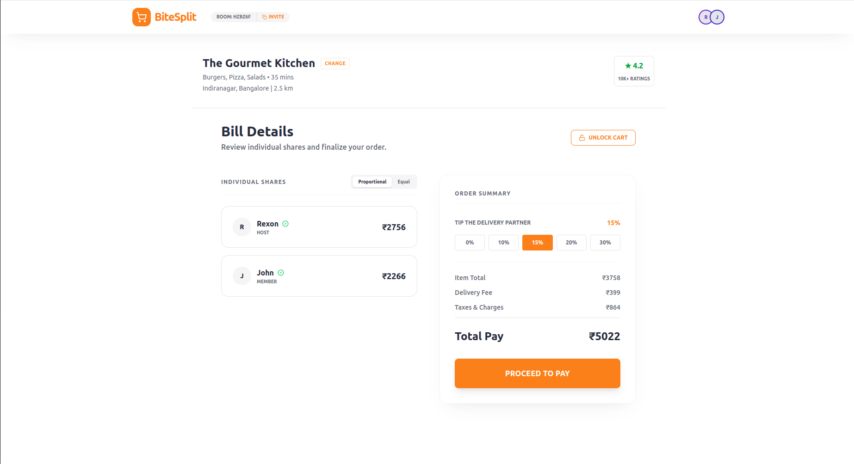  All approved — Proceed to Pay unlocks.

5. Order placed, tracked together
Once paid, everyone lands on a shared confirmation with a live tracking timeline — Preparing → Picked up → Arriving → Delivered — plus the participant list and the total paid.
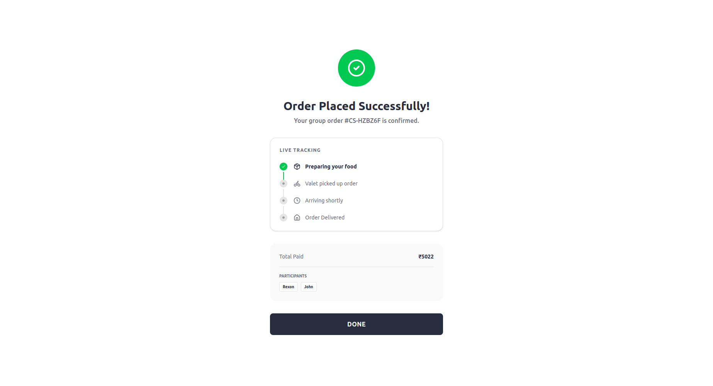
Shared order confirmation and live tracking for the whole group.

Key Design Decisions
- Make the cart the hero, not the menu. In a group app the shared cart is the whole reason you’re here, so it gets persistent real estate — a sticky sidebar on desktop, a slide-up sheet on mobile.
- Borrow a visual language people trust. Money and other people are involved; novelty would cost trust. Clean white surfaces, a confident orange accent, and clear typography buy instant comfort.
- Built for two contexts at once. Guests join on phones; the host often checks out on a laptop — so the layout is genuinely fluid, not one design squeezed into the other.
- The host is a referee, not a gatekeeper. The host controls flow (lock, checkout, pay) but never people’s choices — members approve their own shares.
- No minimum order. A ₹520 side of fries is a valid order; the product serves the lightest member as gracefully as the biggest.

The Hard Part: Getting the Money Exactly Right
A bill splitter that’s off by a rupee isn’t a rounding quirk — it’s a broken promise, because the host absorbs the gap.
- Floating-point money is a trap. 0.1 + 0.2 is 0.30000000000000004. So calculations run on integers in the smallest unit (paise) and only convert back to rupees for display.
- The split has to reconcile. Proportional or equal, the sum of all shares equals subtotal + delivery + taxes + tip exactly — the stray rounding rupee is assigned deterministically.
- The guarantee. A ₹3,758 cart became a ₹5,022 total split as ₹2,756 + ₹2,266 — and those add back to ₹5,022 exactly. That reconciliation is the feature.

Edge Cases I Designed For
- Host switches restaurant mid-session → all carts and totals clear instantly, so menus can’t cross-contaminate.
- A guest refreshes or drops connection → room state is preserved and they rejoin straight into their own cart.
- Cart locked at checkout → adds and removes freeze, so no one alters the order after shares are computed.
- Someone leaves the group → every remaining member’s split is recomputed live.

Outcome & Takeaways
- ~15 minutes → seconds. Group coordination collapses from a long chat thread to everyone tapping on their own phone.
- Host anxiety, designed out. Accurate shares, visible approvals, and a guarantee they’re never short.
- Full stack, solo, in a week. Real-time sync, a self-reconciling split engine, and a complete join-to-delivery flow — proof that AI pair-programming lets one designer own the whole product while still deciding what’s correct and what feels right.
Designed & built by Visvesvaran K — UI/UX Designer & Frontend Developer.

